# Room Rentals Application

Aim: To provide a platform where user can easily find room, house, apartment for rent

narration/motto/ catchphrase : NO hassle , No broker, direct contact with owner with verified listings

### Possible new features

* Virtual tour (for premium listing) ***
* Scheduling for visit
* Provide lease agreement (if needed)
* Customer can send directly visit requests to owner
* Verified listing by local visit (for premium listing)
* Packers and movers integration

Reference sites:

NoBroker:

[Flats, Houses, Apartments for Rent, Buy, Sale Without Brokerage in India](https://www.nobroker.in/)

Badi:

[Rooms and Apartments for Rent | Badi](https://badi.com/)

Flatfair:

[flatfair | Rental solutions & protection for landlords and tenants](https://www.flatfair.co.uk/)

## Features:

### Common Features:

* Should be able to register and sign in using email, google, WhatsApp
  + All account related settings should be able to be changed/modified
    - Password reset / account recovery
* Flag fake listings, Report Users

The Features are separated into two categories for two types of users: Tenants and Landlords

**Tenant Features**

* Search and Filter listings according following criteria:
  + Location (API integration required for exact location)
  + Types of Rental Properties:
    - Residential: Flat, House, Business (shops, offices, clinics, showrooms, co-working spaces), Office Space, Apartment, Single Room, Hostel/PG
    - Commercial: Flat, House, Business, Office Space
  + Layout Type: 1RK (1 Room + Kitchen), 1BHK (1 Bedroom, Hall and Kitchen), 2BHK, 3BHK, 4BHK, 4+BHK, Studio
  + Price
  + Availability: Immediate, within 15 day, within 30 days, 30+ days
  + Preferred Tenant: Family, Bachelor Male, Bachelor Female, Company, Friends
  + Amenities:
    - Room:
      * Furnishings (Furnished, Partial-Furnished, Not Furnished),
      * Air Condition, Heater, Hot Water (Geyser/Solar)
      * Kitchen Equipment (Cooking), Fridge,
      * Wi-Fi, Power Backup
      * Attached Bathroom
      * Balcony
    - Property:
      * CCTV, Security
      * Bike Parking, Car Parking
      * Drainage, Waste Disposal
      * Drinking Water, 24x7 Water (Type of Water Supply – Boring, Well, Municipal, Tanker)
      * Accessibility
  + Pets Allowed? Smoking Allowed?
  + Verified or not?
* View each individual listings that contains following information
  + Name of the Property: Decide on Naming Convention
  + Listing Price
  + Verified Location (Integrated with Google Maps)
  + Property Area
  + Room Layout Type: Layout Type: 1RK (1 Room + Kitchen), 1BHK (1 Bedroom, Hall and Kitchen), 2BHK, 3BHK, 4BHK, 4+BHK, Studio
  + Video and Images
  + Preferred Tenant: Family, Bachelor Male, Bachelor Female, Company, Friends
  + Amenities as listed above
  + Description
  + Other Details
    - Floor in building
    - Age of Building
    - Property Facing
* Tenant should be able to like a listing and save it for later.
* Tenant should be able to call, and message landowner (chat-messaging) – both landowner contact number and email should be verified.
* Tenant should be able to schedule a visit to the property – only after the approval by landowner.
* Tenant should be able to book the property after the landlord’s approval (Integration with esewa and the likes). A Lease Agreement will be created after successful coming together after which only the lease/payments should be paid.
* Should be able to pay monthly rent from the application.
* Tenant should be able to see the following Dashboards:
  + Appointment Dashboards
  + Booking Dashboards
  + Shortlist Dashboards
  + Monthly Rent Dashboard
* Tenant should be able to pay subscription fee for additional benefits:
  + Verified properties only
  + Ad-free experience
* Should be able to use Packers and Movers service if a booking is confirmed. This service will be an in-app movement only i.e. this cannot be used without booking being confirmed.

**Landlord Features:**

* Should be able to register account as Landlord before putting their first property on rent **
  + Following information should be inserted
    - Full Name
    - Phone Number (Verified / OTP)
    - Email Address (Verified)
    - Identifying Document (Citizenship, Passport, Driving License, PAN) ** how to verify from our end?
* Should be able to draft listings.
* Should be able to put their properties in rent with following information
  + Property Name (Title)
  + Location (Integrated with Google Map)
  + Property Type: Residential, Commercial
  + Types of Rental Properties:
    - Residential: Flat, House, Business (shops, offices, clinics, showrooms, co-working spaces), Office Space, Apartment, Single Room, Hostel/PG
    - Commercial: Flat, House, Business, Office Space
  + Layout Type: 1RK (1 Room + Kitchen), 1BHK (1 Bedroom, Hall and Kitchen), 2BHK, 3BHK, 4BHK, 4+BHK, Studio
  + Price
  + Photos (5 mandatory)
  + Video (Mandatory)
  + Availability: Immediate, within 15 day, within 30 days, 30+ days
  + Preferred Tenant: Family, Bachelor Male, Bachelor Female, Company, Friends
  + Amenities:
    - Room:
      * Furnishings (Furnished, Partial-Furnished, Not Furnished),
      * Air Condition, Heater, Hot Water (Geyser/Solar)
      * Kitchen Equipment (Cooking), Fridge,
      * Wi-Fi, Power Backup
      * Attached Bathroom
      * Balcony
    - Property:
      * CCTV, Security
      * Bike Parking, Car Parking
      * Drainage, Waste Disposal
      * Drinking Water, 24x7 Water (Type of Water Supply – Boring, Well, Municipal, Tanker)
      * Accessibility
* Should be able to approve property visit requests by tenants
* Should be able to approve tenants online and accept booking price online after approval.
* Should be able to see Owner Dashboards
  + Appointments Dashboards
  + Booking Dashboards
  + Monthly Rent Dashboards

Admin Features (for verifications and other tasks):

* Should be able to edit and delete a listing.
* Should be able to view and approve or deny the reports for reported listings. Approve will delete the listing, and deny will keep the listing as it is.
* Suspend, block, or delete a user account.
* Should be able to review account information, especially the Identification Document to approve it.

Initial ERD per requirement

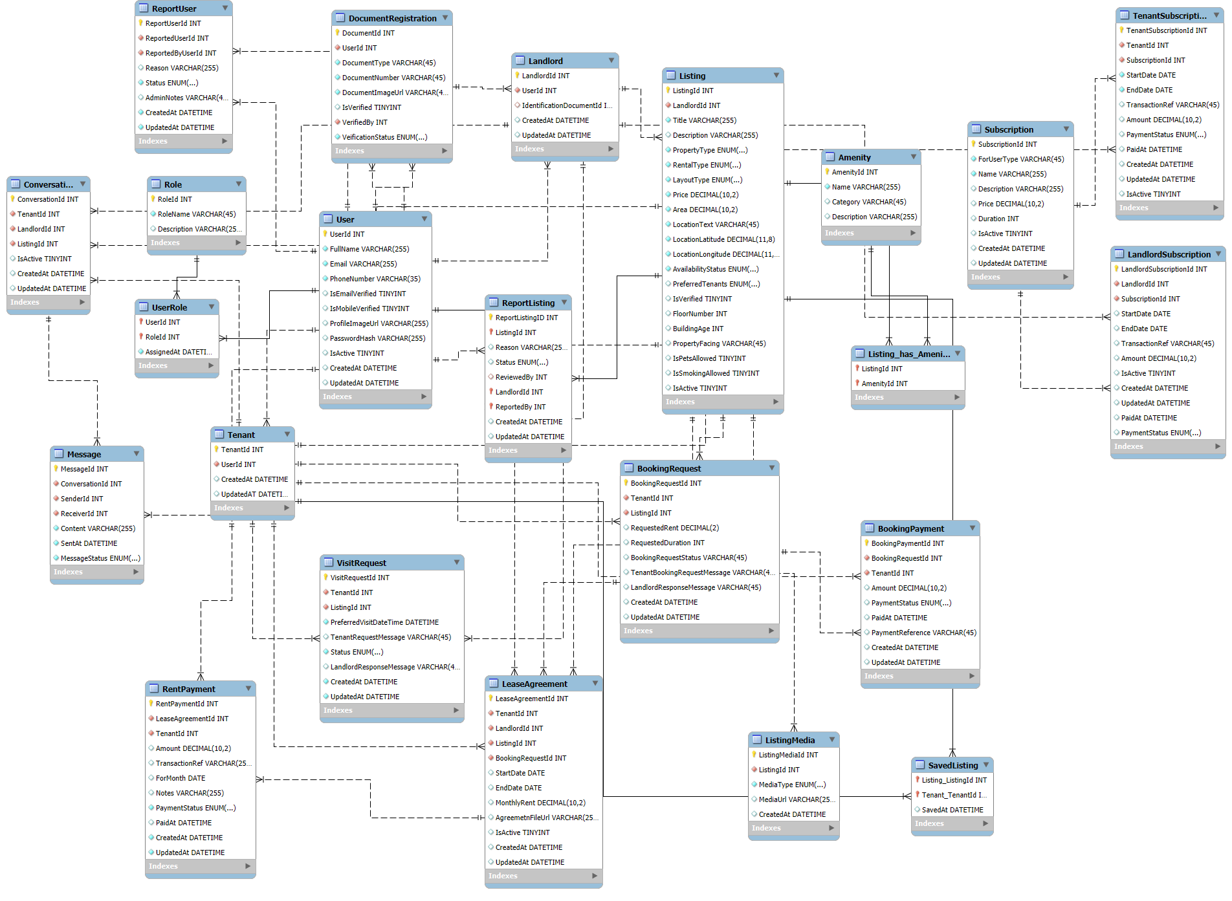

* Lookup tables will be added for each ENUM() used

<https://drive.google.com/file/d/19DwxUJm8Qi2Qmj63LZve4l1uty-ViM4d/view?usp=sharing>